**Dan Koskiranta**

**G00397054**

**Group B**

**Internet Technology 2**

**Lab 1: Understanding of a Hub Network**

**2 February 2023**

**Address Table**

|  |  |  |
| --- | --- | --- |
| Host (device name) | IP Address (unique) | Mask (same for all) |
| PC0 | 192.168.1.100 | 255.255.255.0 |
| PC1 | 192.168.1.101 | 255.255.255.0 |
| PC2 | 192.168.1.102 | 255.255.255.0 |
| PC3 | 192.168.1.103 | 255.255.255.0 |
| PC4 | 192.168.1.104 | 255.255.255.0 |
| PC5 | 192.168.1.105 | 255.255.255.0 |

**Picture of the network**

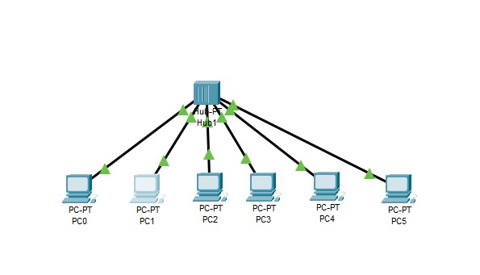

Every PC is connected to the hub which connects the PCs together. This way the devices can communicate with each other within this network. The hub only allows communication inside the network. If you want to connect to outside networks, you need a router for this.

If PC0 wants to communicate with PC5 it will send a signal to the hub and the hub will resend this signal to all other PCs within this network. The hub is unable to store MAC addresses so it’s unable differentiate between the devices on the network. Every message will be shared among each computer on the network.

**PC0 connected to the network. Same ping command executed for every PC.**

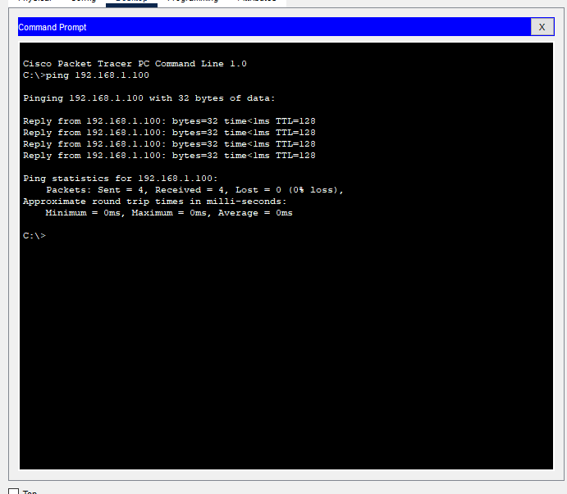

**PC0 is not connected to the hub.**

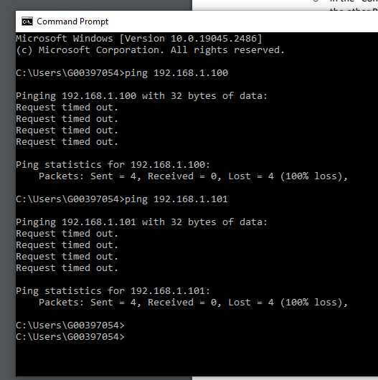

If one PC goes down, it does not affect the network functionality. It just means that you cannot communicate with that PC.

If a connection is broken, it means that you can’t connect to the hub, and you can’t communicate with the other PCs.

If the hub breaks down, the entire network will fail. The computers are not connected and there’s no communication. If a router is connected to the hub, then the PCs will also lose access to external networks.